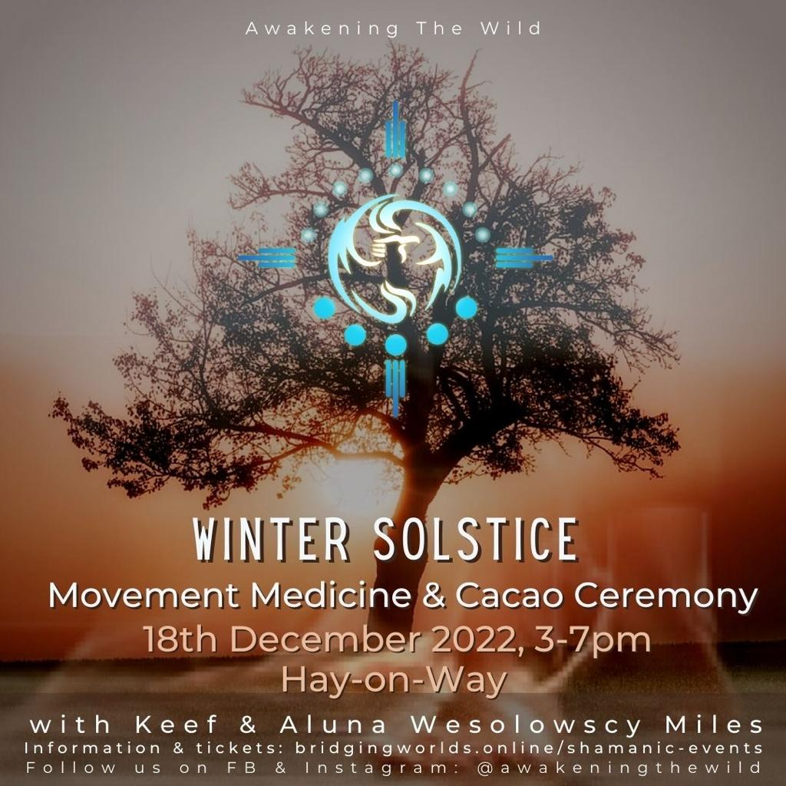

Winter Solstice Movement Medicine and Cacao Ceremony

“This is the solstice, the still point of the sun, its cusp and midnight, year’s threshold and unlocking, where the past lets go of and becomes the future; the place of caught breath.” Margaret Atwood

Join us for a deep and nourishing dive into a simple, yet powerful, ceremony to celebrate Winter Solstice. Movement Medicine and Cacao will be our primary resources on this journey together. This is a time of dreaming, of gathering, of songs, music and stories around the fire. It is a time of coming together to nourish our bodies, hearts and minds. With an eclectic medicine bag of Movement Medicine tools and teachings on offer we invite you to root deeply, dance wildly and resource yourself in these unprecedented times we are living through on our beautiful Mother Earth. There is an abundance of energy available to us when we remember we are elemental beings intrinsically interconnected through the web of life. Keef and Aluna will encourage you with poetic inspiration and rhythmic soul food and serve up an eclectic mix of tribal-rhythms, indigenous-inspirations, songs, mantras, drums and rattle. We will give thanks and praise to this day, this life, this moment. This is the way we pray. This is the way we meet the day. This is The Choice (if you choose): Say YES to life today and dance.

THIS IS A MIXED EVENT. Men and Women welcome, but no children please for this one.

“MOVEMENT MEDICINE is shamanic medicine for our times. It gives us direct, embodied experience of the dance of life that’s going on inside us and all around us. As a species, we face enormous challenges right now that we see as arising from the story of separation; separation between body and spirit, between individuals and nations, between the human world and the web of life we are part of and depend upon. Simply put, Movement Medicine reconnects us, deepening our capacity for empathy and compassionate being and action. Since prehistory, dance, song and ritual-making have played an important role in the human community. Movement Medicine is a contemporary expression of this inheritance. It marries ancient and modern wisdom, and supports you to experience the transformative power of your own potential in co-creative community.” Susannah and Ya'acov Darling Kahn (Co-Founders of The School of Movement Medicine)

CACAO
In many traditions, especially in Central and South America, Cacao is seen as a sacred plant medicine and celebrated for its capacity to open hearts to feeling, intimacy and deepening grounded empathy. To quote Alex Pardhy: “Did you know that cacao contains theophylline? And that theophylline is routinely given for the acute management of severe asthma? Why? Because it relaxes the smooth muscles of the bronchial airways and pulmonary blood vessels - opening the lungs & their blood supply. This is the physiological reason why cacao ‘opens the heart’ so to speak. Add in the feel good compounds of serotonin, anandamide & the high levels of muscle relaxing magnesium and you have a cocktail of chest opening, shoulder relaxing magic. I love it when science and the rhetoric of the spiritual/medicine scene meld into one another. The ‘heart opening effects of cacao’ really are biologically happening.”

Aluna and Keef Wesolowscy Miles

As a couple we are Awakening The Wild. We produce a wide range of nourishing and healing events and programmes, both online and in-person, including rituals, ceremonies, gatherings in nature, workshops, courses, circles of men and circles of women. Individually we offer 1-1 mentoring and group work and love to share our creative medicine in many mediums. We believe in the genius of humanity to grow, adapt, heal and create beauty. We recognise the need for connection, movement, touch, space to breathe, places to create together, to heal together, to sing and dance and laugh together, to sit around the sacred fire together, to reconnect to nature and our own true natures and to tell good stories, life-affirming stories.

WHAT TO BRING? Bring water and comfortable clothes to move in. Bare feet or dancing shoes. Open mind, heart and a body that is willing and able to find the rhythm and move.

MAKE A WEEKEND OF IT
On Saturday 17th December, 1300-2100, we will be holding a WInter Solstice Cabana Purification Lodge along with other Shamanic dynamics, music, song and ritual on 11 acres of beautiful land and forest with a river running through in Llaneglwys LD2 3BQ.

Full address and directions on booking. Standard Price £75. Gifting £95. Scholarships available on application.

Affordable accommodation options are available for Friday, Saturday and Sunday nights if you are travelling any distance and wish to stay locally and enjoy the winter splendour of the Brecon Beacons and beyond. <click here to book> or email keef@bridgingworlds.online

Location:
The Globe at Hay: Institute of Art and Ideas

Standard £25
Gifting* £35
*this option enables us to open up places for those with financial limitations.

Scholarship*
* We have a few reduced price places available on application.
Please email keef@bridginworlds.online.

